Pipelines of Marker Development for

Transcriptome-based Exon Capture

*Part I phylogenomics*

January 17, 2015

Contributors: Sonal Singhal and Ke Bi

For questions or to report bugs, please contact Ke Bi ([kebi@berkeley.edu](mailto:kebi@berkeley.edu))

Reference:

[1]. Singhal S. 2013. De novo transcriptomic analyses for non-model organisms: an evaluation of methods across a multi-species data set. Molecular Ecology Resources 13:403-416.

[2]. Bi K, Linderoth T, Vanderpool D, Good JM, Nielsen R and Moritz C. 2013. Unlocking the vault: next‐generation museum population genomics. Molecular Ecology 22:6018-6032.

[3]. Bi K, Vanderpool D, Singhal S, Linderoth T, Moritz C and Good JM. 2012. Transcriptome-based exon capture enables highly cost-effective comparative genomic data collection at moderate evolutionary scales. BMC Genomics 13: e403.

The pipelines are deposited in

https://github.com/CGRL-QB3-UCBerkeley/MarkerDevelopmentPylogenomics ________________________________________________________________________

Scripts included in this pipeline:

1-PreCleanup

2-ScrubReads

3-GenerateAssemblies

4-AssemblyEvaluation

5-Annotation

6-MarkerSelectionTRANS

6-MarkerSelectionEXONS

**Use “chmod +x script” to make each of these perl scripts executable.

**Note: If exon identification is not possible or not desirable, users can use the entire transcripts for marker development. In this case please use “6- MarkerSelectionTRANS”. Otherwise please use “6- MarkerSelectionEXONS”.

________________________________________________________________________

\**1-PreCleanup*\*: Reformats raw cDNA sequencing reads from Illumina HiSeq or MiSeq for *2-ScrubReads*. Specifically, in this step we will remove reads that did not pass the Illumina quality control filters and modify the sequence identifiers.

Dependencies:

FastQC: http://www.bioinformatics.babraham.ac.uk/projects/fastqc/

**Input:**

Raw sequence data files are grouped and saved in folders named by their sample IDs. For instance, three libraries (CGRL_index1, CGRL_index15, CGRL_index40) are saved under “/home/ke/Desktop/SeqCap/data/rawdata/library/”. Compressed fastq sequence files are saved in each of these folders.

Fastq files use the following naming scheme:  
<sample name>_<barcode sequence>_L<lane (0-padded to 3 digits)>_R<read number>_<set number (0-padded to 3 digits)>.fastq.gz

For example, in “CGRL_index15_CGACCTG_L006_R1_001.fastq.gz”:

sample name: CGRL_index15

barcode sequence: CGACCTG

lane (0-padded to 3 digits): 006

read number: 1

set number (0-padded to 3 digits): 001

#Make a new folder called “raw” under “~/Desktop/MarkerDevelopment/data/rawdata/”:

*ke@NGS:~/Desktop/MarkerDevelopment/data/rawdata$ mkdir raw*

#Copy all these compressed fastq files from each folder (CGRL_index1, CGRL_index15, CGRL_index40) to “raw”:

*ke@NGS:~/Desktop/MarkerDevelopment/data/rawdata$ cp library/CGRL_index*/*.gz raw/*

#Check data files in “raw”:

*ke@NGS:~/Desktop/MarkerDevelopment/data/rawdata$ ls raw/\**

*CGRL_index15_CGACCTG_L006_R1_001.fastq.gz*

*CGRL_index15_CGACCTG_L006_R2_001.fastq.gz*

*CGRL_index1_TCGCAGG_L006_R1_001.fastq.gz*

*CGRL_index1_TCGCAGG_L006_R2_001.fastq.gz*

*CGRL_index40_TTCGCAA_L006_R1_001.fastq.gz*

*CGRL_index40_TTCGCAA_L006_R2_001.fastq.gz*

**Commands:**

#cd to the working directory:

*ke@NGS:~/Desktop/MarkerDevelopment/data/rawdata$ cd ..*

#run 1-PreCleanup with fastq evaluation

*ke@NGS:~/Desktop/MarkerDevelopment/data$ 1-PreCleanup ~/Desktop/MarkerDevelopment/data/rawdata/raw/ fastqc*

*~/Desktop/MarkerDevelopment/data*

**Output:**   
Three new folders will be created under “~/Desktop/MarkerDevelopment/data/rawdata/raw/”:

“pre-clean”

“combined”

“pre-clean/evaluation”

- Folder “pre-clean” contains reformatted raw fastq reads.

CGRL_index1_R1.fq

CGRL_index1_R2.fq

CGRL_index15_R1.fq

CGRL_index15_R2.fq

CGRL_index40_R1.fq

CGRL_index40_R2.fq

- Folder “combined” contains merged, compressed, fastq data files (not used by the following pipeline).

CGRL_index1_TCGCAGG_L006_R1.fastq.gz

CGRL_index1_TCGCAGG_L006_R2.fastq.gz

CGRL_index15_CGACCTG_L006_R1.fastq.gz

CGRL_index15_CGACCTG_L006_R2.fastq.gz CGRL_index40_TTCGCAA_L006_R1.fastq.gz

CGRL_index40_TTCGCAA_L006_R2.fastq.gz

- Folder “evaluation” contains fastQC results for each data file.

CGRL_index1_R1.fq_fastqc/

CGRL_index1_R2.fq_fastqc/

CGRL_index15_R1.fq_fastqc/

CGRL_index15_R2.fq_fastqc/

CGRL_index40_R1.fq_fastqc/

CGRL_index40_R2.fq_fastqc/

________________________________________________________________________

\**2-ScrubReads*\*: Clean up raw data, which includes trimming for quality, removing adapters, merging overlapping reads, removing duplicates and reads sourced from contamination

Dependencies:

cutadapt: http://code.google.com/p/cutadapt/

COPE: http://sourceforge.net/projects/coperead/

Bowtie2: http://sourceforge.net/projects/bowtie-bio/files/bowtie2/

FastQC: http://www.bioinformatics.babraham.ac.uk/projects/fastqc/

FLASh-modified: modified version of FLASh by Filipe G. Vieira. https://github.com/MVZSEQ/Exon-capture

Trimmomatic: http://www.usadellab.org/cms/?page=trimmomatic

**Input:**

1. Reformatted fastq files created by *1-PreCleanup*:

#Check the raw data files:

*ke@NGS:~/Desktop/MarkerDevelopment/data/rawdata/raw/pre-clean$ ls *.fq*

*CGRL_index1_R1.fq*

*CGRL_index1_R2.fq*

*CGRL_index15_R1.fq*

*CGRL_index15_R2.fq*

*CGRL_index40_R1.fq*

*CGRL_index40_R2.fq*

2. A fasta file that contains adapter sequences:

#Check the format of adapter sequence file:

*ke@NGS:~/Desktop/SeqCap/denovoTargetCapture/associated_files $ less -S Adapters.fasta*

*>P7_index1*

*CAAGCAGAAGACGGCATACGAGATcctgcgaGTGACTGGAGTTCAGACGTGTGCTCTTCCGATCT*

*>P7_index2*

*CAAGCAGAAGACGGCATACGAGATtgcagagGTGACTGGAGTTCAGACGTGTGCTCTTCCGATCT*

*……*

*>P5_index1*

*AATGATACGGCGACCACCGAGATCTACACcctgcgaACACTCTTTCCCTACACGACGCTCTTCCGATCT*

*>P5_index2*

*AATGATACGGCGACCACCGAGATCTACACtgcagagACACTCTTTCCCTACACGACGCTCTTCCGATCT*

*……*

Note: The header of each adapter sequence has to be named strictly as “**P7_index**N” or “**P5_index**N”. N is the number of index. It is OK to put all adapters in this file but your libraries only use a subset of them.

3. Library info file (Tab-delimited txt file):

#Check the format of Library info file:

*ke@NGS:~/Desktop/SeqCap/denovoTargetCapture/associated_files $ less -S libInfo.txt*

*library P7 P5*

*CGRL_index1 1*

*CGRL_index15 15*

*CGRL_index40 40*

Leave the “P5” column blank if you only have indexes in P7 adapters in the libraries.

4. Contaminant file:

*Escherichia coli* (bacteria + human + other genome resources if desired) genome in fasta format.

This file (e_coli_K12.fasta) is saved in “~/Desktop/SeqCap/denovoTargetCapture/associated_files/ecoli/”

**Commands:**

#Make a new folder called “cleaned_data” in “~/Desktop/MarkerDevelopment/data/”:

*ke@NGS:~/Desktop/MarkerDevelopment/data$ mkdir cleaned_data*

#Run *2-ScrubReads*:

*ke@NGS:~/Desktop/MarkerDevelopment/data$ 2-ScrubReads -f ~/Desktop/MarkerDevelopment/data/rawdata/raw/pre-clean/ -o ~/Desktop/MarkerDevelopment/data/cleaned_data/ -a ~/Desktop/SeqCap/denovoTargetCapture/associated_files/Adapters.fasta -b ~/Desktop/SeqCap/denovoTargetCapture/associated_files/libInfo.txt -t /home/ke/Desktop/SeqCap/programs/Trimmomatic-0.32/trimmomatic-0.32.jar -c ~/Desktop/SeqCap/denovoTargetCapture/associated_files/ecoli/e_coli_K12.fasta -e 200 -m 15 -z*

Note: I use the default values for most of the arguments. Users should adjust these parameters when processing the real datasets.

**Output:**

1. In “~/Desktop/MarkerDevelopment/data/cleaned_data/”, six .txt files per library are produced:

 For example for library CGRL_index1, the six files are:

CGRL_index1_1_final.txt (left reads)

CGRL_index1_2_final.txt (right reads)

CGRL_index1_u_final.txt (merged or unpaired reads)

CGRL_index1.contam.out  (headers of reads aligned to bacteria)

CGRL_index1.duplicates.out   (headers of duplicated reads)

CGRL_index1.lowComplexity.out (headers of low complexity reads)

2. In “~/Desktop/MarkerDevelopment/data/cleaned_data/evaluation/”, you can find fastQC results for cleaned reads from each library.

\**3-GenerateAssemblies*\*: Assemble RNAseq data using Trinity.

Dependencies:

Trinity <http://trinityrnaseq.sourceforge.net>

**Input:**

For each library, we will concatenate cleaned forward reads (XXX_1_final.txt) and unpaired reads (XXX_u_final.txt) and name the resulting read data file as XXX_1_final.txt.

#Make a new folder called “raw_assembly” under “~/Desktop/MarkerDevelopment/data/”:

*ke@NGS:~/Desktop/MarkerDevelopment/data$ mkdir raw_assembly*

#Concatenate cleaned forward reads and unpaired reads and save them in “raw_assembly”:

*ke@NGS:~/Desktop/MarkerDevelopment/data$ cat cleaned_data/CGRL_index1_1_final.txt cleaned_data/CGRL_index1_u_final.txt | sed 's/\/2$/\/1/g' > raw_assembly/CGRL_index1_1_final.txt*

*ke@NGS:~/Desktop/MarkerDevelopment/data$ cat cleaned_data/CGRL_index15_1_final.txt cleaned_data/CGRL_index15_u_final.txt | sed 's/\/2$/\/1/g' > raw_assembly/CGRL_index15_1_final.txt*

*ke@NGS:~/Desktop/MarkerDevelopment/data$ cat cleaned_data/CGRL_index40_1_final.txt cleaned_data/CGRL_index40_u_final.txt | sed 's/\/2$/\/1/g' > raw_assembly/CGRL_index40_1_final.txt*

#Copy read2 of all libraries to “raw_assembly”

*ke@NGS:~/Desktop/MarkerDevelopment/data$ cp cleaned_data/CGRL_index*_2_final.txt raw_assembly/*

**Commands:**

#Run Trinity on 4 processors.

*ke@NGS:~/Desktop/MarkerDevelopment/data$ 3-GenerateAssemblies trinity -a raw_assembly/ -c 5 -e 4*

Note: Your labtop may not be able to handle Trinity assemblies.

**Output**:

There are quite a few intermediate files generated in “~/Desktop/MarkerDevelopment/data/raw_assembly/CGRL_index1/”.

“~/Desktop/MarkerDevelopment/data/raw_assembly/CGRL_index15/”.

“~/Desktop/MarkerDevelopment/data/raw_assembly/CGRL_index40/”.

#To show final trinity assemblies that are needed for annotation:

*ke@NGS:~/Desktop/MarkerDevelopment/data$ ls raw_assembly/CGRL_index*/*.fasta*

*raw_assembly/CGRL_index15/CGRL_index15.fasta*

*raw_assembly/CGRL_index1/CGRL_index1.fasta*

*raw_assembly/CGRL_index40/CGRL_index40.fasta*

#Under “~/Desktop/MarkerDevelopment/data/” make a new folder called “annotation” and copy all files shown above to this folder:

*ke@NGS:~/Desktop/MarkerDevelopment/data$ mkdir annotation*

*ke@NGS:~/Desktop/MarkerDevelopment/data$ cp raw_assembly/CGRL_index*/*.fasta annotation/*

#check all files in folder “annotation”

*ke@NGS:~/Desktop/MarkerDevelopment/data$ ls annotation/\**

*annotation/CGRL_index15.fasta*

*annotation/CGRL_index40.fasta*

*annotation/CGRL_index1.fasta*

*########################################################*

**When we did step1-3 we used a tiny fraction of the RNAseq data for the purpose of quick demonstration. To better demonstrate how to use the next script (4-AssemblyEvaluation) let’s sample some more data from each individual.**

**Please do the following before you start working on step 4:**

**ke@NGS:~/Desktop/MarkerDevelopment/data$ cp ~/Desktop/MarkerDevelopment/associated_data/CGRL_index*.fasta**  **annotation/**

*########################################################*

________________________________________________________________________

*\*4-AssemblyEvaluation\** (Optional): Evaluate the quality of cDNA *de novo* assemblies. A few examples of the available functions are shown here.

Dependencies:

Blat: <http://hgdownload.soe.ucsc.edu/downloads.html#source_downloads>

Blastall: http://blast.ncbi.nlm.nih.gov/Blast.cgi?PAGE_TYPE=BlastDocs&DOC_TYPE=Download

**Input:** Trinityassemblies for all libraries stored in “~/Desktop/MarkerDevelopment/data/annotation/”

#Display all items in “~/Desktop/MarkerDevelopment/data/annotation/”

*ke@NGS:~/Desktop/MarkerDevelopment/data/annotation$ ls*

*CGRL_index15.fasta*

*CGRL_index1.fasta*

*CGRL_index40.fasta*

*a. 4-AssemblyEvaluation BASIC*: function “BASIC” evaluates the quality of in-target assemblies by reporting basic stats: mean, median, total length, gc%, N50 etc. It also generates a distribution of contigs by binned lengths.

**Commands:**

*ke@NGS:~/Desktop/MarkerDevelopment/data $ 4-AssemblyEvaluation BASIC -a* annotation/

**Output:**

# In folder “~/Desktop/MarkerDevelopment/data/annotation/”, you should get the following output files:

*CGRL_index15.hist*

*CGRL_index1.hist*

*CGRL_index40.hist*

*basic_evaluation.out*

**Output:**

1. “XXX. hist” shows distribution of contigs by binned lengths

#Display first few lines of the file:

*ke@NGS:~/Desktop/MarkerDevelopment/data/annotation$ head CGRL_index15.hist*

*200:299 57*

*300:399 43*

*400:499 34*

*500:599 28*

*600:699 25*

*700:799 23*

*800:899 18*

*900:999 24*

*1000:1099 13*

*1100:1199 6*

2. “basic_evaluation.out”: results of assembly evaluation

#Display first few lines of the file:

*ke@NGS:~/Desktop/MarkerDevelopment/data/annotation$ head basic_evaluation.out*

b. *4-AssemblyEvaluation ANNOTATABLE*: Calculates the percentage of the assembled contigs that get a match in reference. It also calculates average percentage of matched bp and mismatches among the matched genes.

**Commands:**

*ke@NGS:~/Desktop/MarkerDevelopment/data$ 4-AssemblyEvaluation ANNOTATABLE -a annotation/ -b 100 -c ~/Desktop/MarkerDevelopment/associated_data/Xenopus_tropicalis.JGI_4.2.cdna.all.fa*

**Output:**

#Display results in the output file “annotatable.out”:

*ke@NGS:~/Desktop/MarkerDevelopment/data/annotation$ less annotatable.out*

Assemblies total matches(%) matched bases(%) avg similarity(%)

CGRL_index1 100.00 61.91 78.55

CGRL_index15 98.00 58.38 77.36

CGRL_index40 96.00 68.23 78.17

c. *4-AssemblyEvaluation ACCURACY*: The percentage of the correctly assembled bases estimated using the set of expressed reference transcripts

**Commands:**

*ke@NGS:~/Desktop/MarkerDevelopment/data$ 4-AssemblyEvaluation ACCURACY -a annotation/ -b 300 -c ~/Desktop/MarkerDevelopment/associated_data/Xenopus_tropicalis.JGI_4.2.pep.all.fa*

**Output:**

#Display results in the output file “accuracy.out”:

*ke@NGS:~/Desktop/MarkerDevelopment/data/annotation$ less accuracy.out*

*Assemblies stop codon(%) gaps(%)*

*CGRL_index1 0.000 0.000*

*CGRL_index15 0.692 0.000*

*CGRL_index40 0.348 0.000*

d. *4-AssemblyEvaluation CONTIGUITY* : Calculates assembly contiguity (the percentage of expressed reference transcripts covered by a single, longest assembled contig) and completeness (the percentage of expressed reference transcripts covered by all matched assembled contigs)

**Commands:**

*ke@NGS:~/Desktop/MarkerDevelopment/data$ 4-AssemblyEvaluation CONTIGUITY -a annotation/ -b 300 -c ~/Desktop/MarkerDevelopment/associated_data/Xenopus_tropicalis.JGI_4.2.cdna.all.fa*

**Note: that –b in function “CONTIGUITY” refers to the number of randomly selected sequences from the reference protein database. In functions “BASIC”, “ANNOTATABLE” and “ACCURACY” –b refers to the number of randomly selected sequences in de novo assemblies**

**Output:**

#Display results in the output file “Contiguity.out”:

*ke@NGS:~/Desktop/MarkerDevelopment/data/annotation$ less Contiguity.out*

*Assemblies complete(%) contiguity(%)*

*CGRL_index1 13.46 11.47*

*CGRL_index15 23.36 23.36*

*GRL_index40 37.40 30.21*

________________________________________________________________________

*\*5-Annotation\**: annotate assembled contigs using a related reference protein dataset that can be found in Ensembl Genome Browser (http://www.ensembl.org/index.html)

Dependencies:

BLAST+: <http://blast.ncbi.nlm.nih.gov/Blast.cgi?PAGE_TYPE=BlastDocs&DOC_TYPE=Download>

FrameDP: <https://iant.toulouse.inra.fr/FrameDP/cgi-bin/framedp.cgi?__wb_cfg=/www/iant/FrameDP/cgi-bin/../cfg/FrameDP.cfg&__wb_session=WBuPAWHo&__wb_main_menu=Download&__wb_function=Download>

exonerate: <http://www.ebi.ac.uk/~guy/exonerate/index.html>

**Note: this script works only if you can find a reference database from the EGB. However, if you would like to use NCBI refseq, NR or UniProtKB/Swiss-Prot, modification of this script is needed.

** Swiss-Prot (created in 1986) is a high quality manually annotated and non-redundant protein sequence database, which brings together experimental results, computed features and scientific conclusions. UniProtKB/Swiss-Prot is now the reviewed section of the UniProt Knowledgebase.

**FrameDP: Sensitive peptide detection on noisy matured sequences. A self-training integrative pipeline for predicting CDS in transcripts which can adapt itself to different levels of sequence qualities.

**Input:**

1. download a reference protein dataset from the Ensembl:

Step1. Go to the Ensembl homepage <http://www.ensembl.org/> and click on “Download” located at the top.

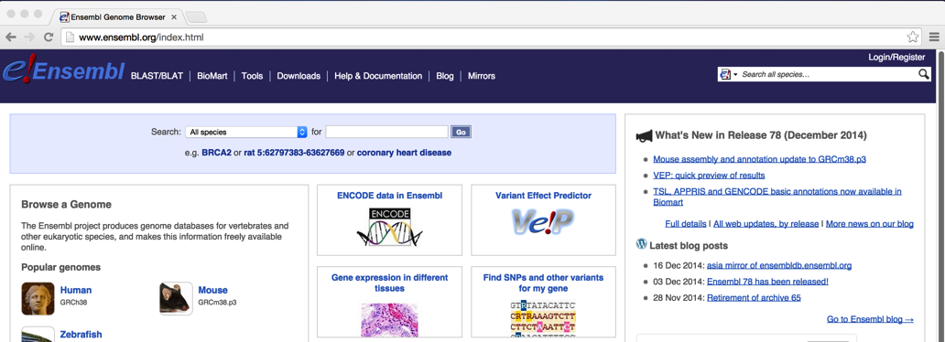

Step2. Click on “Download data via FTP” to the left of the download page.

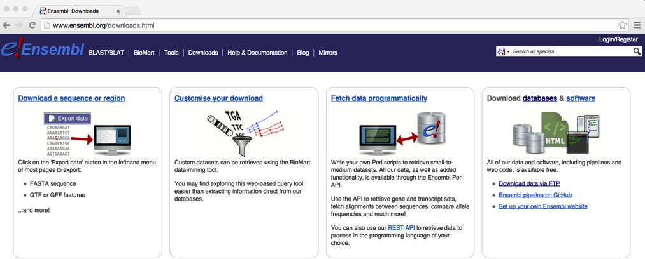

Step3. Select “All” in the “single species data” box in the FTP download page.

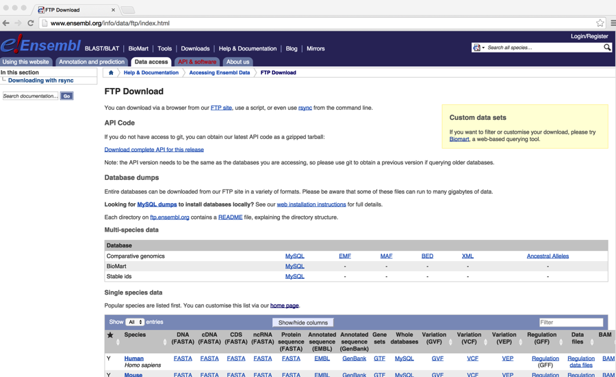

Step 4: Find and download the reference. Click on the FASTA link for Protein sequence. In this case we choose *Xenopus tropicalis* as the reference.

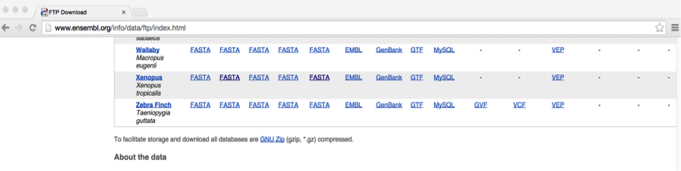

Step 5: From FTP server, download reference protein fasta “XXX.pep.all. fa.gz”

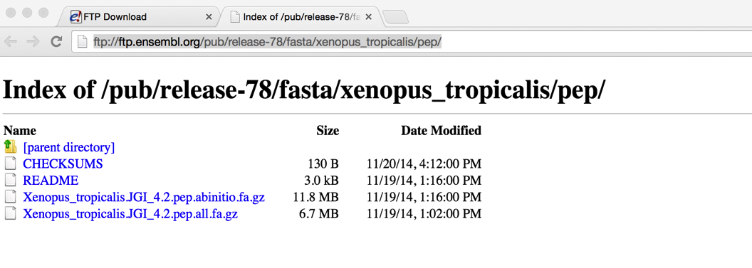

Step 6: unzip the downloaded reference fasta: *gunzip Xenopus_tropicalis.JGI_4.2.pep.all. fa.gz*

Step 7: Find and download the GTF (Gene transfer format (GTF) is a file format used to hold information about gene structure) if there is one available for the reference. In this case we can see that *Xenopus tropicalis* has a GTF so we can download it.



Step 8: unzip the downloaded GTF: *gunzip Xenopus_tropicalis.JGI_4.2.78.gtf.gz*

2. If GTF is not available then you can use Ensembl BioMart tool to obtain a gene annotation file for the reference. For the workshop I will show you how obtain this file from the BioMart tool even though we have downloaded a GTF for the reference.

Step1. Go to the Ensembl homepage <http://www.ensembl.org/> and click on “BioMart” located at the top.

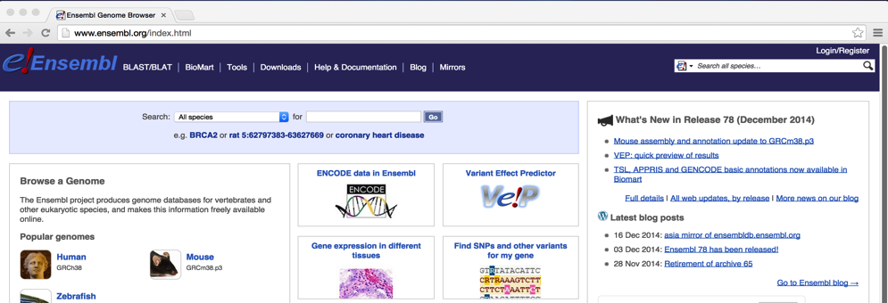

Step2. In the BioMart homepage, select “Ensembl Genes 78” and “Xenopus tropicalis genes (JGI4.2)”.

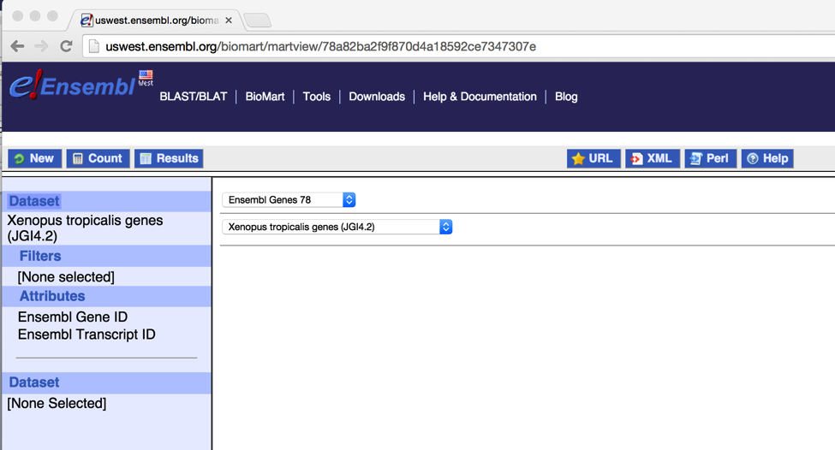

Step3. Click on “Attributes” icon to the left.

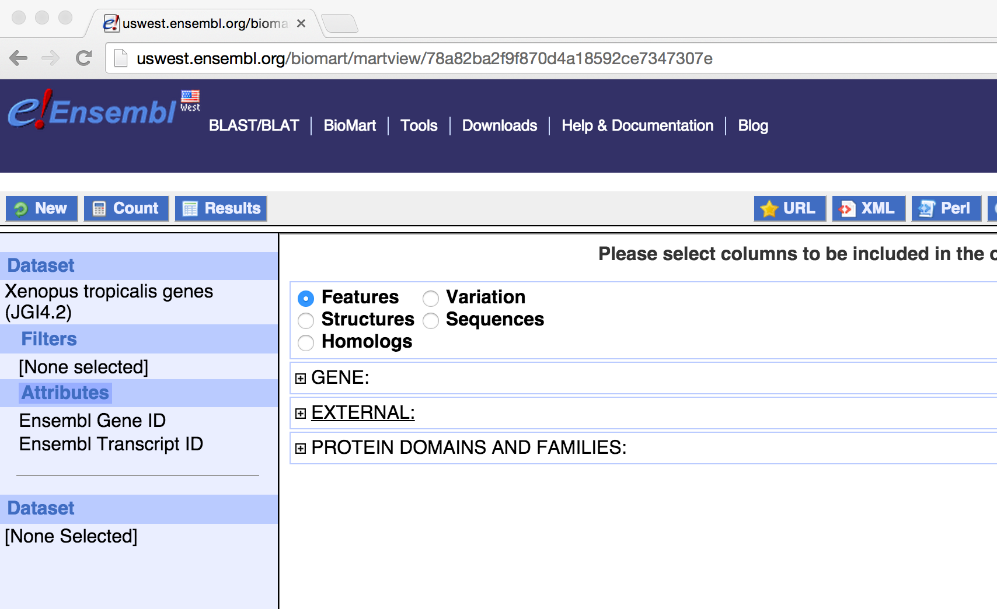

Step 4. Click on “GENE” to expand the manual. Check on “Ensembl Gene ID” and “Associated Gene Name”.

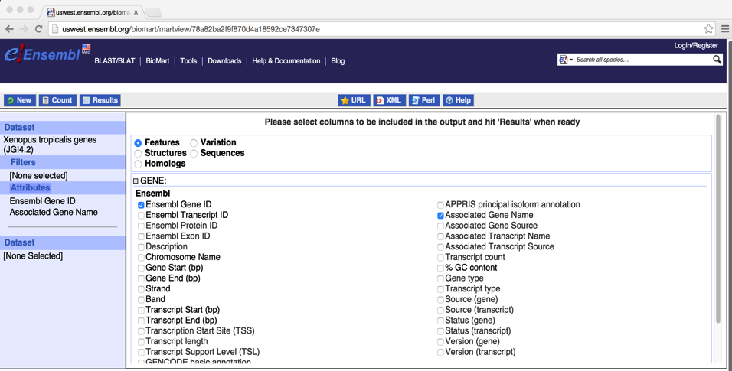

Step 5. Scroll down the window to find “EXTERNAL”. Click on it to expand the manual. Check on “WikiGene Description”

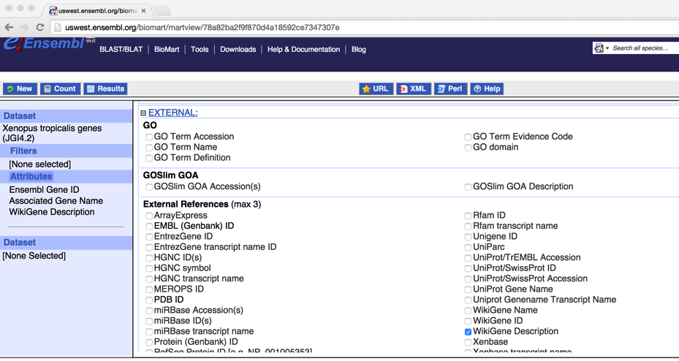

Step6. Click on “Results” icon.

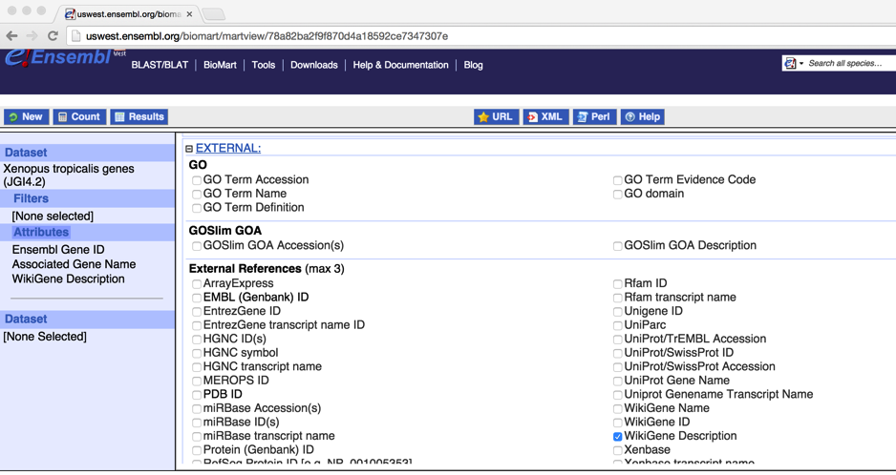

Step 7. To export the results, select “CSV” format and check on “Unique results only” box, and then click on “Go”.

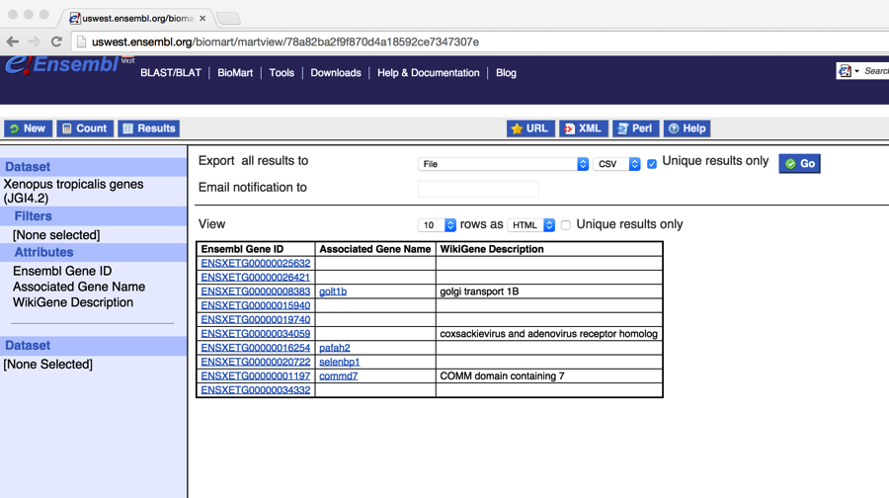

Step 8. Save and rename the result to be “*Xenopus.tropicalis* _gene_name.txt”. There are three columns, separated by comma:

Ensembl Gene ID, Associated Gene Name, WikiGene Description

ENSXETG00000008383, golt1b, golgi transport 1B

ENSXETG00000034059, CARH, coxsackievirus and adenovirus receptor homolog

ENSXETG00000001197, commd7, COMM domain containing 7

**……**

**For this workshop, a reference protein, a GTF and the corresponding biomart gene name file are already downloaded and located in “~/Desktop/MarkerDevelopment/associated_data/”.

**Input:**

1. A folder that contains all trinity assemblies. These files are located in “~/Desktop/MarkerDevelopment/data/annotation/”

2. Reference protein downloaded from the ensemble: Xenopus_tropicalis.JGI_4.2.pep.all.fa.

3. Reference biomart gene annotation file:

Xenopus_tropicalis_gene_name.txt

***OR***

4. Reference GTF file:

*Xenopus_tropicalis.JGI_4.2.78.gt****f***

**Commands:**

# Run 5-Annotation without a GTF (do not execute the command during the workshop, since the runs will take quite a while to finish).

*ke@NGS:~/Desktop/MarkerDevelopment/data$ 5-Annotation -a ~/Desktop/MarkerDevelopment/data/annotation/ -b ~/Desktop/MarkerDevelopment/associated_data/Xenopus_tropicalis.JGI_4.2.pep.all.fa -d ~/Desktop/SeqCap/programs/framedp-1.2.2/ -f ~/Desktop/MarkerDevelopment/associated_data/Xenopus_tropicalis_gene_name.txt -n xenopus -e 1*

**##Copy the annotation results to “*~/Desktop/MarkerDevelopment/data*”**

***ke@NGS:~/Desktop/MarkerDevelopment/data$ scp -r ~/Desktop/MarkerDevelopment/associated_data/annotation/* annotation/***

**Output:**

For each individual trinity assembly, a new folder is generated under “~/Desktop/MarkerDevelopment/data/annotation/”:

CGRL_index1_xenopus/

CGRL_index14_xenopus /

CGRL_index40_xenopus /

##The annotated fasta files are named as “XXX_xenopus_annotated.fasta”.

*ke@NGS:~/Desktop/MarkerDevelopment/data/annotation$ ls CGRL_index*/*annotated.fasta*

*CGRL_index15_xenopus/CGRL_index15_xenopus_annotated.fasta CGRL_index50_xenopus/CGRL_index50_xenopus_annotated.fasta CGRL_index1_xenopus/CGRL_index1_xenopus_annotated.fasta*

##make a new folder “probe_design” under “~/Desktop/MarkerDevelopment/data/”.

*ke@NGS:~/Desktop/MarkerDevelopment/data$ mkdir probe_design*

##copy all the annotated fasta files to “*probe_design*”

*ke@NGS:~/Desktop/MarkerDevelopment/data$ cp annotation/CGRL_index*/*annotated.fasta probe_design/*

## read and display the first few lines in the annotated fasta file:

*ke@NGS:~/Desktop/MarkerDevelopment/data/probe_design$ head -4 CGRL_index15_xenopus_annotated.fasta*

>contig1 gs1_ge432 ENSXETG00000014175 vwa5a NA 5e-57 TCTCTTACATGGACCCTTCC……

>contig10 5u355_gs356_ge817_3u818 ENSXETG00000004176 mocs2 molybdenum cofactor synthesis 2 2e-82

TGTGCACAGTGTGATGTAG……

For contig1: “gs1” means coding region starts at position 1. “ge432” means coding region ends by position 432. No UTRs are present in this contig. “ENSXETG00000014175” is the Ensembl gene ID obtained from Xenopus reference database. “vwa5a” is the gene name. “NA” is the wiki gene description and in this case, wiki gene description is missing. “5e-57” is e-value in the BLAST search.

For contig10: “5u355” means 5UTR ends by position 355. “gs356” means coding region starts at position 356. “ge817” means coding region ends by position 817. “3u818” means 3UTR starts at position 818. “ENSXETG00000004176” is the Ensembl gene ID obtained from Xenopus reference database. “mocs2” is the gene name. “molybdenum cofactor synthesis 2” is the wiki gene description. “2e-82” is e-value in the BLAST search.

~~~~~~~~~~~~~~~~~~~~~~~~~~~~~~~~~~~~~~~~~~~~~~~~~~

Run 5-Annotation with a GTF

**Commands:**

*ke@NGS:~/Desktop/MarkerDevelopment$ 5-Annotation -a ~/Desktop/MarkerDevelopment/data/annotation/ -b ~/Desktop/MarkerDevelopment/associated_data/Xenopus_tropicalis.JGI_4.2.pep.all.fa -d ~/Desktop/SeqCap/programs/framedp-1.2.2/ -n xenopus -g ~/Desktop/MarkerDevelopment/associated_data/Xenopus_tropicalis.JGI_4.2.78.gtf -e 1*

The output by using GTF is slightly different since the header doesn’t have gene name descriptions. For example:

>contig1 gs1_ge432 ENSXETG00000014175 vwa5a protein_coding 5e-57

TCTCTTACATGGACCCTTCC……

“gs1” means coding region starts at position 1. “ge432” means coding region ends by position 432. No UTRs are present in this contig. “ENSXETG00000014175” is the Ensembl gene ID obtained from Xenopus reference database. “vwa5a” is the gene name. **“protein_coding” is the type of the gene**. “5e-57” is e-value in the BLAST search.

\**6-MarkerSelectionTRANS*\*: Find orthologous transcripts in transcriptomes from different species and generate input files for probe design. It can be used when exon identification is impossible and/or is not preferred.

Dependencies:

BLAST+: <http://blast.ncbi.nlm.nih.gov/Blast.cgi?PAGE_TYPE=BlastDocs&DOC_TYPE=Download>

MUSCLE: <http://www.drive5.com/muscle/>

cd-hit-est: <http://weizhongli-lab.org/cd-hit/>

First of all we want to identify orthologous transcripts across transcriptomes from different species. We will run the command “6-MarkerSelectionTRANS markers*”* for this task:

**Input:**

All annotated transcripts located in “~/Desktop/MarkerDevelopment/data/probe_design”

##

*ke@NGS:~/Desktop/MarkerDevelopment/data/probe_design$ ls*

*CGRL_index15_xenopus_annotated.fasta*

*CGRL_index40_xenopus_annotated.fasta*

*CGRL_index1_xenopus_annotated.fasta*

**Commands:**

# Run *6-MarkerSelectionTRANS markers:*

*ke@NGS:~/Desktop/MarkerDevelopment/data$ 6-MarkerSelectionTRANS markers -f probe_design/ -a 1000*

**Output:**

#Under “ke@NGS:~/Desktop/MarkerDevelopment/data/probe_design/” a new folder called “results” was created by the script.

*ke@NGS:~/Desktop/MarkerDevelopment/data/probe_design$ cd results/*

#Markers that passed all filters are stored in “marker_kept.txt”. First take a How many markers are kept?

*ke@NGS:~/Desktop/MarkerDevelopment/data/probe_design/results$ wc -l marker_kept.txt*

*1050 marker_kept.txt*

*ke@NGS:~/Desktop/MarkerDevelopment/data/probe_design/results$ less -S marker_kept.txt*

**Transcript_name**: Ensembl Gene ID

**avgDiv**: Average sequence divergence (avg. %mismatches)

**varianceDiv**: Variance of sequence divergence

**avgLength**: Average length of the marker

**avgGC**: Average CG content of the marker

**div_CGRL_index15_xenopus_annotated _vs_CGRL_index1_xenopus_annotated**: sequence divergence between CGRL_index15 and CGRL_index1

**div_CGRL_index15_xenopus_annotated _vs_CGRL_index40_xenopus_annotated**: sequence divergence between CGRL_index15 and CGRL_index40

**div_CGRL_index1_xenopus_annotated _vs_CGRL_index40_xenopus_annotated**: sequence divergence between CGRL_index1 and CGRL_index40

#Select the markers that you would like to use for probe design. In this case choose the most variable 800 markers and save them in a new file “marker_final.txt”

*ke@NGS:~/Desktop/MarkerDevelopment/data/probe_design/results$ tail -800 marker_kept.txt > marker_final.txt*

++++++++++++++++++++++++++++++++++

Now we will use command “6-MarkerSelectionTRANS seq*”* to generate input fasta files for probe design:

**Input:**

1. A final set of markers you would like to use for probe design - “~/Desktop/MarkerDevelopment/data/probe_design/results/marker_final.txt”

2. A folder containing all trimmed transcripts in fasta format. These files were created by “6-MarkerSelectionTRANS markers” and are named as XXX.final2 – “~/Desktop/MarkerDevelopment/data/probe_design/results/”

**Commands:**

# Run *6-MarkerSelectionTRANS seq:*

*ke@NGS:~/Desktop/MarkerDevelopment/data$ 6-MarkerSelectionTRANS seq -f probe_design/results/marker_final.txt -d probe_design/results/*

*The target size for CGRL_index15_xenopus _annotated.final2 is 700532bp!*

*The target size for CGRL_index1_xenopus _annotated.final2 is 701541bp!*

*The target size for CGRL_index40_xenopus _annotated.final2 is 701593bp!*

**Output:**

#A new folder “Probe_Design” was created by the script. cd to this folder:

*ke@NGS:~/Desktop/MarkerDevelopment/data/probe_design/results$ cd Probe_Design/*

#Three fasta sequence files contain sequences of orthologous markers are generated and ready for submission for probe design:

*ke@NGS:~/Desktop/MarkerDevelopment/data/probe_design/results/Probe_Design$ ls *exonic_targets.txt*

*CGRL_index15_xenopus _annotated_exonic_targets.txt*

*CGRL_index1_xenopus _annotated_exonic_targets.txt*

*CGRL_index40* *_xenopus _annotated_exonic_targets.txt*

________________________________________________________________________

\**6-MarkerSelectionEXONS*\*: Find orthologous exons in transcriptomes from different species and generate input files for probe design.

Dependencies:

exonerate: <http://www.ebi.ac.uk/~guy/exonerate/index.html>

cd-hit-est: <http://weizhongli-lab.org/cd-hit/>

BLAST+: <http://blast.ncbi.nlm.nih.gov/Blast.cgi?PAGE_TYPE=BlastDocs&DOC_TYPE=Download>

MUSCLE: <http://www.drive5.com/muscle/>

We will run “6-MarkerSelectionEXONS exons” to identify orthologous exons in transcriptomes from each of the species.

**If a .gtf file is not available then we will first use a protein and genome reference to identify exons from reference species. We will then use the identified exons from the reference to identify ortholgous exons from each of the transcriptomes.

**However, if a .gtf file is available then I recommend first run “ParseGTF” to obtain exonic sequences from the reference and then run “6-MarkerSelectionEXONS exons”.

++++++++++++++++++++++++++++++++++++++++++++++++++++++++

First of all we assume no .gtf is available so we have to identify exons using a reference protein and reference genome.

**Input:**

1. Under “~/Desktop/MarkerDevelopment/data/” make a new folder “probe_design_exons/”:

*ke@NGS:~/Desktop/MarkerDevelopment/data$ mkdir probe_design_exons/*

2. copy all annotated transcripts to “~/Desktop/MarkerDevelopment/data/probe_design_exons”.

*ke@NGS:~/Desktop/MarkerDevelopment/data$ cp probe_design/CGRL_index1_xenopus_annotated.fasta probe_design/other_files/CGRL_index* probe_design_exons/*

*ke@NGS:~/Desktop/MarkerDevelopment/data$ cd probe_design_exons/*

*ke@NGS:~/Desktop/MarkerDevelopment/data/probe_design_exons$ ls*

*CGRL_index15* *_xenopus _annotated.fasta*

*CGRL_index40* *_xenopus _annotated.fasta*

*CGRL_index1* *_xenopus _annotated.fasta*

3. Repeat-masked reference genome “Xenopus_tropicalis.JGI_4.2.dna_rm.nonchromosomal.fa”

4. A reference protein reference “Xenopus_tropicalis.JGI_4.2.pep.all.fa”;

Both 3 and 4 can be downloaded through Ensembl following the instruction above. For this workshop these two files are located under “~/Desktop/MarkerDevelopment/associated_data”.

**Command:**

#Run “6-MarkerSelectionEXONS exons”

*ke@NGS:~/Desktop/MarkerDevelopment/data$ 6-MarkerSelectionEXONS exons -p '/home/ke/Desktop/MarkerDevelopment/associated_data/Xenopus_tropicalis.JGI_4.2.pep.all.fa' -g '/home/ke/Desktop/MarkerDevelopment/associated_data/Xenopus_tropicalis.JGI_4.2.dna_rm.nonchromosomal.fa' -f ~/Desktop/MarkerDevelopment/data/probe_design_exons -E 1000*

** “*6-MarkerSelectionEXONS exons”* takes very long time to run so please do not run it during the workshop. Let’s skip this step and copy the output files directly from “associated_data”:

*ke@NGS:~/Desktop/MarkerDevelopment/data$ cp ~/Desktop/MarkerDevelopment/associated_data/probe_design_exons/*.nr ~/Desktop/MarkerDevelopment/associated_data/probe_design_exons/marker_* probe_design_exons/*

**Output:**

In “~/Desktop/MarkerDevelopment/data/probe_design_exons/” there are two output files that are relevant for the next step:

1. “marker_kept.txt”: Orthologous exonic markers identified in the three species

2. “marker_kept_one_exon_per_gene.txt” is a subset of “marker_kept.txt”

,which contains randomly selected one exon per gene.

In both 1 and 2, annotation of each column is explained below:

**exon_name**: Exon ID

**avgDiv**: Average sequence divergence (avg. %mismatches)

**varianceDiv**: Variance of sequence divergence

**avgLength**: Average length of the exons

**avgGC**: Average CG content of the exons

**div_CGRL_index15_xenopus _annotated_vs_CGRL_index1_xenopus _annotated**: sequence divergence between CGRL_index15 and CGRL_index1

**div_CGRL_index15_xenopus _annotated_vs_CGRL_index40_xenopus _annotated**: sequence divergence between CGRL_index15 and CGRL_index40

**div_CGRL_index1_xenopus _annotated_vs_CGRL_index40_xenopus _annotated**: sequence divergence between CGRL_index1 and CGRL_index40

+++++++++++++++++++++++++++++++++++++++++++++++++++++++++++++++++

Now I will demonstrate how to use *6-MarkerSelectionEXONS exons* when a gtf is available.

**Command:**

#Run “ParseGTF”:

*ke@NGS:~/Desktop/MarkerDevelopment/data$ ParseGTF -f ~/Desktop/MarkerDevelopment/associated_data/Xenopus_tropicalis.JGI_4.2.78.gtf -g ~/Desktop/MarkerDevelopment/associated_data/Xenopus_tropicalis.JGI_4.2.dna_rm.toplevel.fa -o 100 -p 1*

**do not run ParseGTF in the workshop

**Output:**

#Results are stored in “exons.unique” under

“*/home/ke/Desktop/MarkerDevelopment/associated_data/results*”

#cd to “*/home/ke/Desktop/MarkerDevelopment/associated_data/results*”

*ke@NGS:~/Desktop/MarkerDevelopment/data$ cd ~/Desktop/MarkerDevelopment/associated_data/results/*

#display at the results

*ke@NGS:~/Desktop/MarkerDevelopment/associated_data/results$ less -S exons.unique*

#copy “exons.unique” to “~/Desktop/MarkerDevelopment/data/probe_design_exons/”

*ke@NGS:~/Desktop/MarkerDevelopment/associated_data/results$ cp exons.unique ~/Desktop/MarkerDevelopment/data/probe_design_exons*

#copy all annotated transcripts to “~/Desktop/MarkerDevelopment/data/probe_design_exons/”

*ke@NGS:~/Desktop/MarkerDevelopment/data$ cp probe_design/CGRL_index1_xenopus_annotated.fasta probe_design/other_files/CGRL_index* probe_design_exons/*

**Command:**

#run “6-MarkerSelectionEXONS exons” (do not run it in the workshop)

*ke@NGS:~/Desktop/MarkerDevelopment/data$ 6-MarkerSelectionEXONS exons -p '/home/ke/Desktop/MarkerDevelopment/associated_data/Xenopus_tropicalis.JGI_4.2.pep.all.fa' -g '/home/ke/Desktop/MarkerDevelopment/associated_data/Xenopus_tropicalis.JGI_4.2.dna_rm.toplevel.fa' -f ~/Desktop/MarkerDevelopment/data/probe_design_exons -E 1000*

**Output:**

Same as above:

Now we will run command “6-MarkerSelectionEXONS seq*”* to generate input fasta files for probe design:

**Input:**

1. A final set of markers you would like to use for probe design. In this case we choose to use one exon per gene - “~/Desktop/MarkerDevelopment/data/probe_design/results/ marker_kept_one_exon_per_gene.txt”

2. A folder containing non-redundant exonic markers in fasta format. These files were created by “6-MarkerSelectionEXONS exons” and are named as XXX _exon.fa.nr – “~/Desktop/MarkerDevelopment/data/probe_design_exons/”

**Commands:**

# Run *6-MarkerSelectionEXONS seq:*

*ke@NGS:~/Desktop/MarkerDevelopment/data$ 6-MarkerSelectionEXONS seq -f probe_design_exons/marker_kept_one_exon_per_gene.txt -d probe_design_exons/*

**Output:**

#A new folder “Probe_Design” was created by the script. cd to this folder:

*ke@NGS:~/Desktop/MarkerDevelopment/data/probe_design_exons$ cd Probe_Design/*

#Three fasta sequence files contain sequences of orthologous exonic markers are generated and ready for submission for probe design:

*ke@NGS:~/Desktop/MarkerDevelopment/data/probe_design_exons/Probe_Design$ ls *exonic_targets.txt*

*CGRL_index15_xenopus _annotated_exonic_targets.txt*

*CGRL_index1_xenopus _annotated_exonic_targets.txt*

*CGRL_index40_xenopus _annotated_exonic_targets.txt*